Testing

Using

JUnit
CHAPTER

44





Objectives
- To know what JUnit is and how JUnit works (§44.2).
- To create and run a JUnit test class from the command window (§44.2).
- To create and run a JUnit test class from NetBeans (§44.3).
- To create and run a JUnit test class from Eclipse (§44.4).



44-2 Chapter 44 Testing Using JUnit

Introduction

Key Point
JUnit is a tool for testing Java programs.
At the very beginning of this book in Section 2.16, we introduced software development pro- cess that includes requirements specification, analysis, design, implementation, testing, deploy- ment, and maintenance. Testing is an important part of this process. This chapter introduces how to test Java classes using JUnit.

JUnit Basics

Key Point
To test a class, you need to write a test class and run it through JUnit to generate a report for the class.
JUnit is the de facto framework for testing Java programs. JUnit is a third-party open-source library packed in a jar file. The jar file contains a tool called test runner, which is used to run test programs. Suppose you have a class named A. To test this class, you write a test class named ATest. This test class, called a test class, contains the methods you write for testing class A. The test runner executes ATest to generate a test report, as shown in Figure 44.1.

Test Class File
…
e.g., ATest.class A.class
…
Test Runner
Test Report
FIGuRE 44.1 JUnit test runner executes the test class to generate a test report.

You will see how JUnit works from an example. To create the example, first you need to download JUnit from http://sourceforge.net/projects/junit/files/. At present, the latest version is junit-4.10.jar. Download this file to c:\book\lib and add it to the classpath environment variable as follows:

set classpath=.;%classpath%;c:\book\lib\junit-4.10.jar

To test if this environment variable is set correctly, open a new command window, and type the following command:
java org.junit.runner.JUnitCore

You should see the message displayed as shown in Figure 44.2.
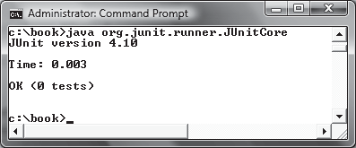
FIGuRE 44.2 The JUnit test runner displays the JUnit version.

To use JUnit, create a test class. By convention, if the class to be tested is named A, the test class should be named ATest. A simple template of a test class may look like this:



44.2 JUnit Basics 44-3
1 package mytest;
2
- import org.junit.*;
- import static org.junit.Assert.*; 5
- public class ATest {
- @Test
- public void m1() {
- // Write a test method
10 }
11
- @Test
- public void m2() {
- // Write another test method
15 }
16
- @Before
- public void setUp() throws Exception {
- // Common objects used by test methods may be set up here
20 }
21 }

This class should be placed in a directory under mytest. Suppose the class is placed under c:\book\mytest. You need to compile it from the mytest directory and run it from c:\book as shown in the following screen shot.

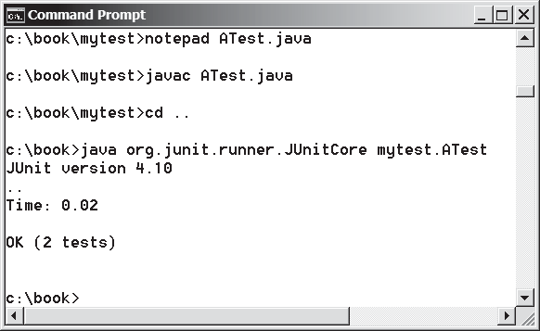

Note that the command to run the test from the console is:

java org.junit.runner.JUnitCore mytest.ATest

When this command is executed, JUnitCore controls the execution of ATest. It first executes the setUp() method to set up the common objects used for the test, and then executes test methods m1 and m2 in this order. You may define multiple test methods if desirable.
The following methods can be used to implement a test method:

assertTrue(booleanExpression)
The method reports success if the booleanExpression evaluates true.
assertEquals(Object, Object)
The method reports success if the two objects are the same using the equals method.
assertNull(Object)
The method reports success if the object reference passed is null.
fail(String)
The method causes the test to fail and prints out the string.




44-4 Chapter 44 Testing Using JUnit

Listing 44.1 is an example of a test class for testing java.util.ArrayList.
LISTING 44.1 ArrayListTest.java
1 package mytest;
2
- import org.junit.*;
- import static org.junit.Assert.*;
- import java.util.*;
6
- public class ArrayListTest {
- private ArrayList<String> list = new ArrayList<String>(); 9
- @Before
- public void setUp() throws Exception {
- }
13
- @Test
- public void testInsertion() {
- list.add("Beijing");
- assertEquals("Beijing", list.get(0));
- list.add("Shanghai");
- list.add("Hongkong");
- assertEquals("Hongkong", list.get(list.size() – 1));
21 }
22
- @Test
- public void testDeletion() {
- list.clear();
- assertTrue(list.isEmpty());
27
- list.add("A");
- list.add("B");
- list.add("C");
- list.remove("B");
- assertEquals(2, list.size());
33 }
34 }

A test run of the program is shown in Figure 44.3. Note that you have to first compile Array- ListTest.java. The ArrayListTest class is placed in the mytest package. So you should place ArrayListTest.java in the directory named mytest.

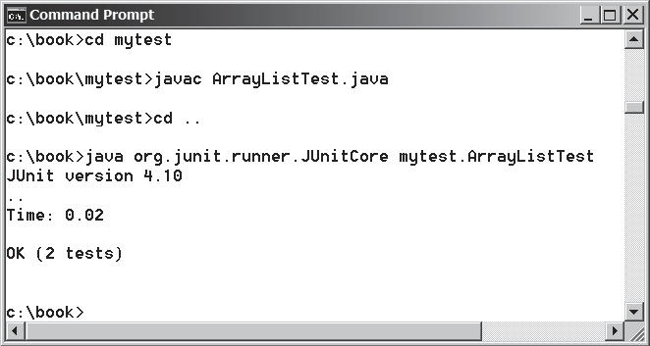
FIGuRE 44.3 The test report is displayed from running ArrayListTest.



  - JUnit Basics 44-5

No errors are reported in this JUnit run. If you mistakenly change
assertEquals(2, list.size());
in line 32 to
assertEquals(3, list.size());
Run ArrayListTest now. You will see an error reported as shown in Figure 44.4.

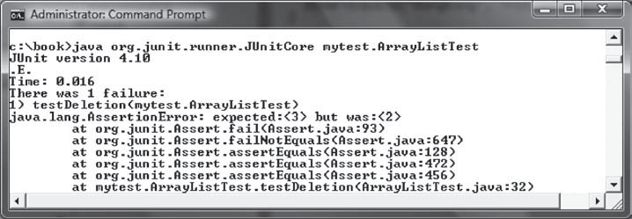
FIGuRE 44.4 The test report reports an error.

You can define any number of test methods. In this example, the two test methods test- Insertion and testDeletion are defined. JUnit executes testInsertion and test- Deletion in this order.


Note
The test class must be placed in a named package such as mytest in this example. The JUnit will not work if the test class is placed a default package.

Listing 44.2 gives a test class for testing the Loan class in Listing 10.2. For convenience, we create Loan.java in the same directory with LoanTest.java. The Loan class is shown in Listing 44.3.
LISTING 44.2 LoanTest.java
1 package mytest;
2
- import org.junit.*;
- import static org.junit.Assert.*; 5
- public class LoanTest {
- @Before
- public void setUp() throws Exception {
- }
10
- @Test
- public void testPaymentMethods() {
- double annualInterestRate = 2.5;
- int numberOfYears = 5;
- double loanAmount = 1000;
Loan loan = new Loan(annualInterestRate, numberOfYears,
16
17 loanAmount);
18

44-6 Chapter 44 Testing Using JUnit

19
loanAmount));
getTotalPayment(annualInterestRate, numberOfYears,
assertTrue(loan.getTotalPayment() ==
loanAmount));
getMonthlyPayment(annualInterestRate, numberOfYears,
assertTrue(loan.getMonthlyPayment() ==
20
21
22
23
24
25 }
26
27 |  | /** Find monthly payment */
28 |  | private double getMonthlyPayment(double annualInterestRate,
29 |  | int numberOfYears, double loanAmount) {
30 |  | double monthlyInterestRate = annualInterestRate / 1200;
31 |  | double monthlyPayment = loanAmount * monthlyInterestRate / (1 –
32 |  | (1 / Math.pow(1 + monthlyInterestRate, numberOfYears * 12)));
33 |  | return monthlyPayment;
34 |  | }
35
36 |  | /** Find total payment */
37 |  | public double getTotalPayment(double annualInterestRate,
38 |  | int numberOfYears, double loanAmount) {
39 |  | return getMonthlyPayment(annualInterestRate, numberOfYears,
40 |  | loanAmount) * numberOfYears * 12;
41 |  | }
42 | }

Listing 44.3 Loan.java
1
package mytest;
2

3
public class Loan
- private double
{
annualInterestRate;



- private int numberOfYears;
- private double loanAmount;
- private java.util.Date loanDate; 8
- /** Default constructor */
- public Loan() {
11 this(2.5, 1, 1000);
12 }
13
- /** Construct a loan with specified annual interest rate,
- number of years, and loan amount
16 */
- public Loan(double annualInterestRate, int numberOfYears,
- double loanAmount) {
- this.annualInterestRate = annualInterestRate;
- this.numberOfYears = numberOfYears;
- this.loanAmount = loanAmount;
- loanDate = new java.util.Date();
23 }
24
- /** Return annualInterestRate */
- public double getAnnualInterestRate() {
- return annualInterestRate;
28 }
29
- /** Set a new annualInterestRate */
- public void setAnnualInterestRate(double annualInterestRate) {
- this.annualInterestRate = annualInterestRate;
33 }



  - JUnit Basics 44-7
34
- /** Return numberOfYears */
- public int getNumberOfYears() {
- return numberOfYears;
38 }
39
- /** Set a new numberOfYears */
- public void setNumberOfYears(int numberOfYears) {
- this.numberOfYears = numberOfYears;
43 }
44
- /** Return loanAmount */
- public double getLoanAmount() {
- return loanAmount;
48 }
49
- /** Set a newloanAmount */
- public void setLoanAmount(double loanAmount) {
- this.loanAmount = loanAmount;
53 }
54
- /** Find monthly payment */
- public double getMonthlyPayment() {
- double monthlyInterestRate = annualInterestRate / 1200;
- double monthlyPayment = loanAmount * monthlyInterestRate / (1 –
- (1 / Math.pow(1 + monthlyInterestRate, numberOfYears * 12)));
- return monthlyPayment;
61 }
62
- /** Find total payment */
- public double getTotalPayment() {
- double totalPayment = getMonthlyPayment() * numberOfYears * 12;
- return totalPayment;
67 }
68
- /** Return loan date */
- public java.util.Date getLoanDate() {
- return loanDate;
72 }
73 }

The testPaymentMethods() in LoanTest creates an instance of Loan (line 16–17) and tests whether loan.getMonthlyPayment() returns the same value as getMonthlyPayment (annualInterestRate, numberOfYears, loanAmount). The latter method is defined in the LoanTest class (lines 28–34).

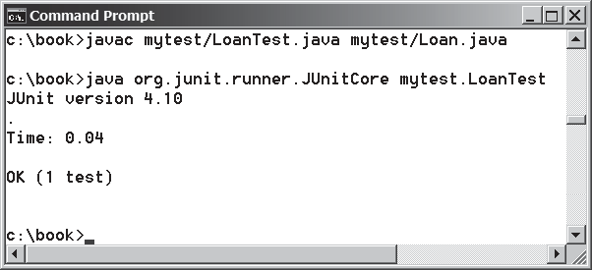
FIGuRE 44.5 The JUnit test runner executes LoanTest and reports no errors.

44-8 Chapter 44 Testing Using JUnit

Check Point

Key Point


The testPaymentMethods() also tests whether loan.getTotalPayment() returns the same value as getTotalPayment(annualInterestRate, numberOfYears, loan- Amount). The latter method is defined in the LoanTest class (lines 37–41).
A sample run of the program is shown in Figure 44.5.

    - What is JUnit?
    - What is a JUnit test runner?
    - What is a test class? How do you create a test class?
    - How do you use the assertTrue method?
    - How do you use the assertEquals method?

Using JUnit from NetBeans
JUnit is intergrated with NetBeans. Using NetBeans, the test program can be auto- matically generated and the test process can be automated.
An IDE such as NetBeans and Eclipse can greatly simplify the process for creating and running test classes. This section introduces using JUnit from NetBeans and the next section introduces using JUnit from Eclipse.
If you are not familiar with NetBeans, see Supplement II.B. Assume you have installed NetBeans 8 or higher. Create a project named chapter44 as follows:
Step 1: Choose File, New Project to display the New Project dialog box.
Step 2: Choose Java in the Categories section and Java Application in the Projects section. Click Next to display the New Java Application dialog box.
Step 3: Enter chapter44 as the Project Name and c:\book as Project Location. Click
Finish to create the project as shown in Figure 44.6.
To demonstrate how to create a test class, we first create a class to be tested. Let the class be
Loan from Listing 10.2. Here are the steps to create the Loan class under chapter44.



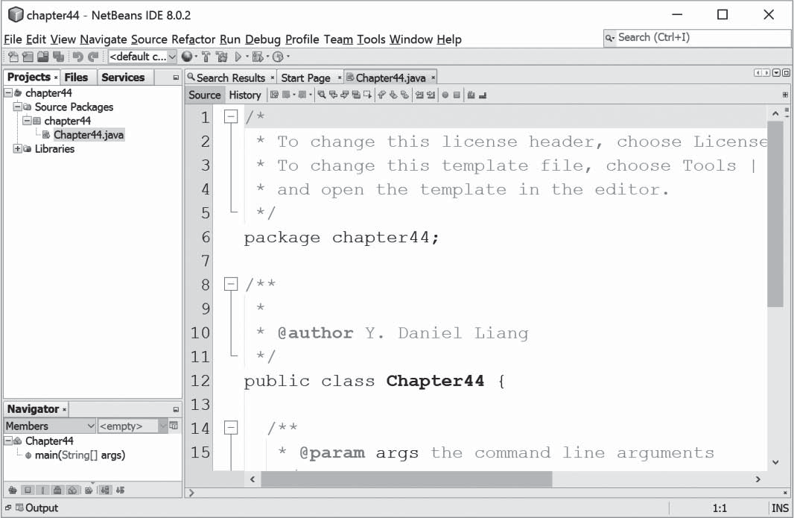
FIGuRE 44.6 A new project named chapter44 is created.



Using JUnit from NetBeans 44-9
Step 1: Right-click the project node chapter44 and choose New, Java Class to display the New Java Class dialog box.
Step 2: Enter Loan as Class Name and chapter44 in the Package field and click Finish
to create the class.
Step 3: Copy the code in Listing 10.2 to the Loan class and make sure the first line is
package chapter44, as shown in Figure 44.7.

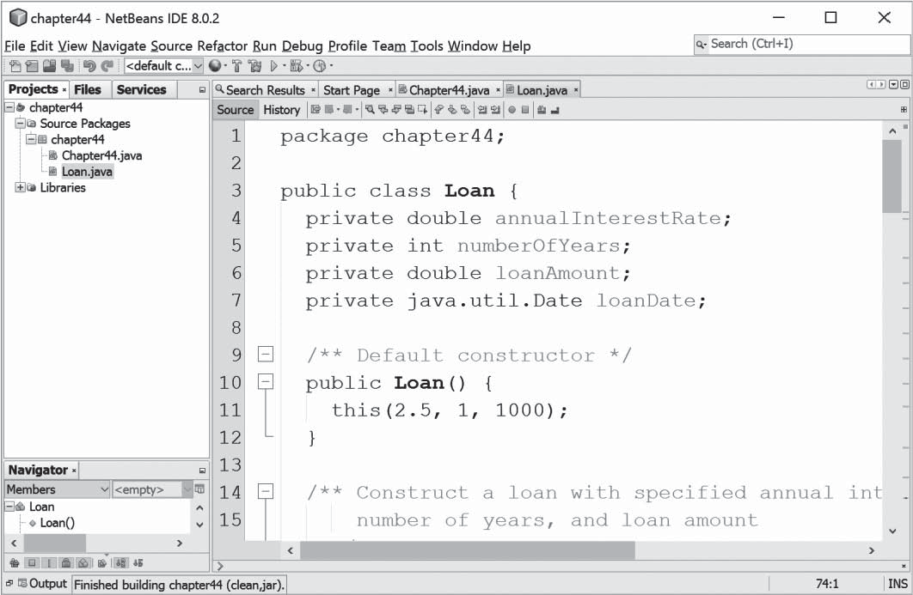
FIGuRE 44.7 The Loan class is created.

Now you can create a test class to test the Loan class as follows:
Step 1: Right-click Loan.java in the project to display a context menu and choose
Tools, Create/Update Test to display the Create Test dialog box, as shown in Figure 44.8.

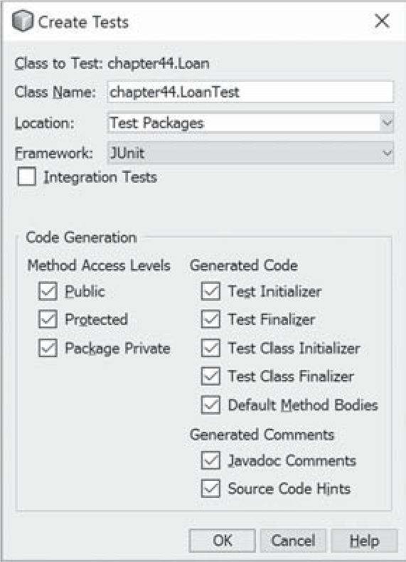
FIGuRE 44.8 The Create Tests dialog box creates a Test class.



44-10 Chapter 44 Testing Using JUnit

Step 2: Click OK. You will see the Select JUnit version dialog box displayed as shown in Figure 44.9. Choose Junit 4.x. Click OK to generate a Test class named LoanTest as shown in Figure 44.10. Note that LoanTest.java is placed under the Test Packages node in the project.

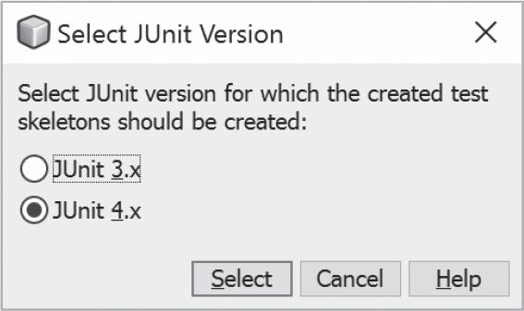
FIGuRE 44.9 You should select JUnit 4.x framework to create test classes.

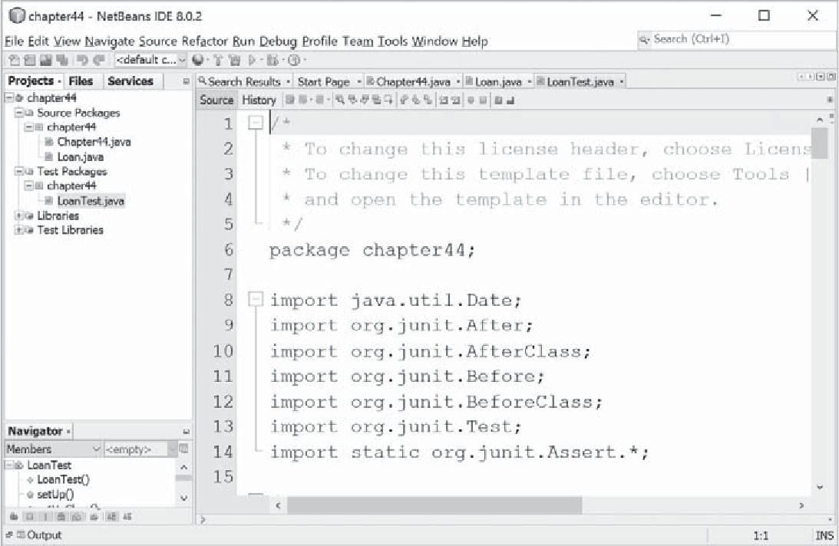

FIGuRE 44.10 The LoanTest class is automatically generated.



Using JUnit from Eclipse 44-11

You can now modify LoanTest by copying the code from Listing 44.2. Run LoanTest.java. You will see the test report as shown in Figure 44.11.

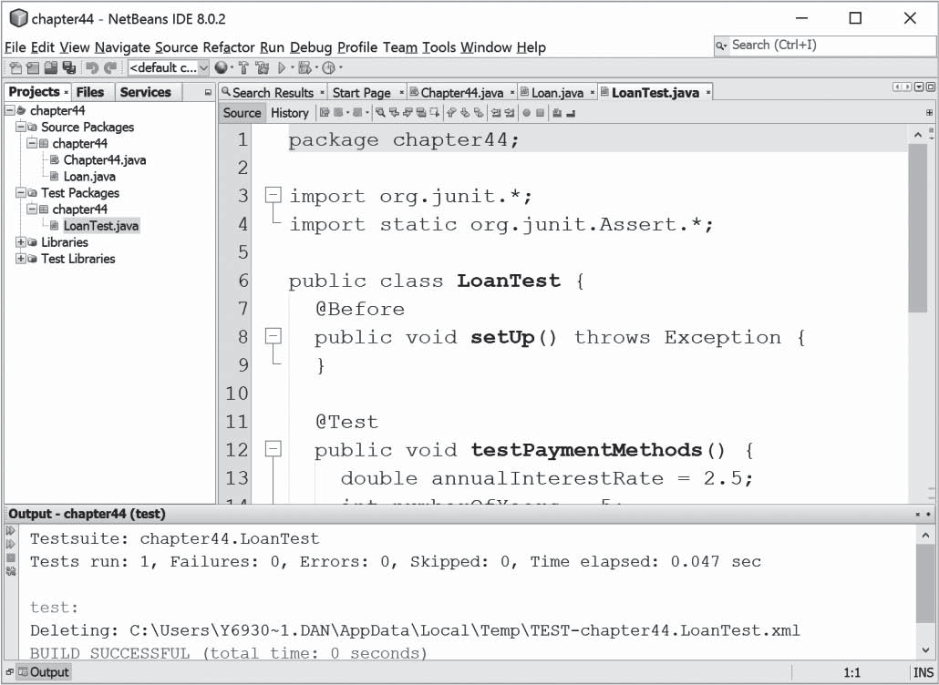
FIGuRE 44.11 The test report is displayed after the LoanTest class is executed.

Using JUnit from Eclipse

Key Point
JUnit is intergrated with Eclipse. Using Eclipse, the test program can be automati- cally generated and the test process can be automated.
This section introduces using JUnit from Eclipse. If you are not familiar with Eclipse, see Supplement II.D. Assume you have installed Eclipse 4.5 or higher. Create a project named chapter50 as follows:
Step 1: Choose File, New Java Project to display the New Java Project dialog box, as shown in Figure 44.12.
Step 2: Enter chapter50 in the project name field and click Finish to create the project.
To demonstrate how to create a test class, we first create a class to be tested. Let the class be
Loan from Listing 10.2. Here are the steps to create the Loan class under chapter44.

44-12 Chapter 44 Testing Using JUnit
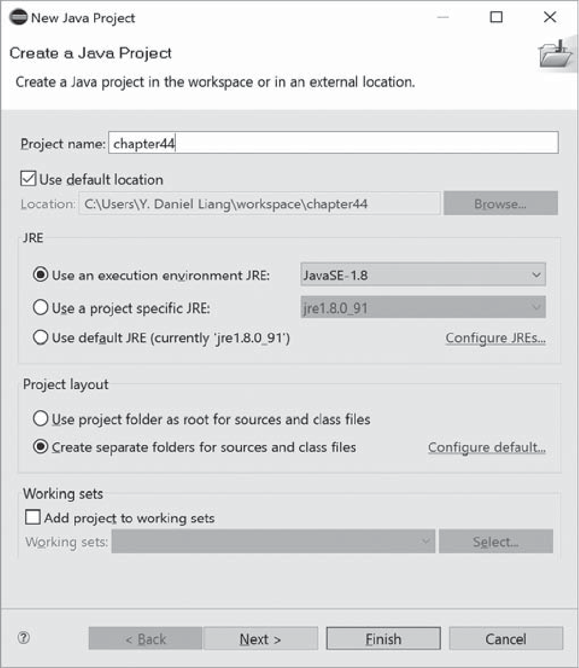
FIGuRE 44.12 The New Java Project dialog creates a new project.

Step 1: Right-click the project node chapter44 and choose New, Class to display the New Java Class dialog box, as shown in Figure 44.13.
Step 2: Enter mytest in the Package field and click Finish to create the class.
Step 3: Copy the code in Listing 10.2 to the Loan class and make sure the first line is
package mytest, as shown in Figure 44.14.
Now you can create a test class to test the Loan class as follows:
Step 1: Right-click Loan.java in the project to display a context menu and choose New, JUnit Test Case to display the New JUnit Test Case dialog box, as shown in Figure 44.15.
Step 2: Click Finish. You will see a dialog prompting you to add JUnit 4 to the project build path. Click OK to add it. Now a test class named LoanTest is created as shown in Figure 44.16.
You can now modify LoanTest by copying the code from Listing 44.2. Run LoanTest.java. You will see the test report as shown in Figure 44.17.

KEy TERMS



JUnit 44-2
JUnitCore 44-2
test class 44-2
test runner 44-2




44.4 Using JUnit from Eclipse 44-13
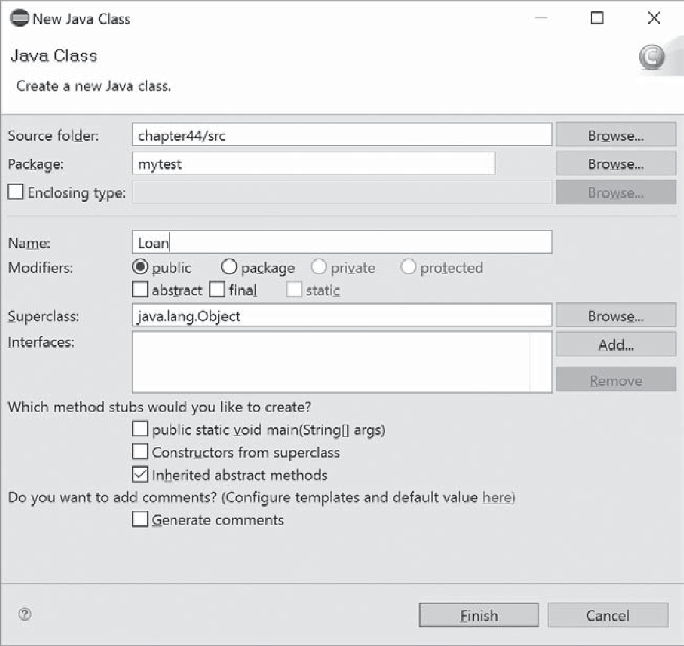

FIGuRE 44.13 The New Java Class dialog creates a new Java class.

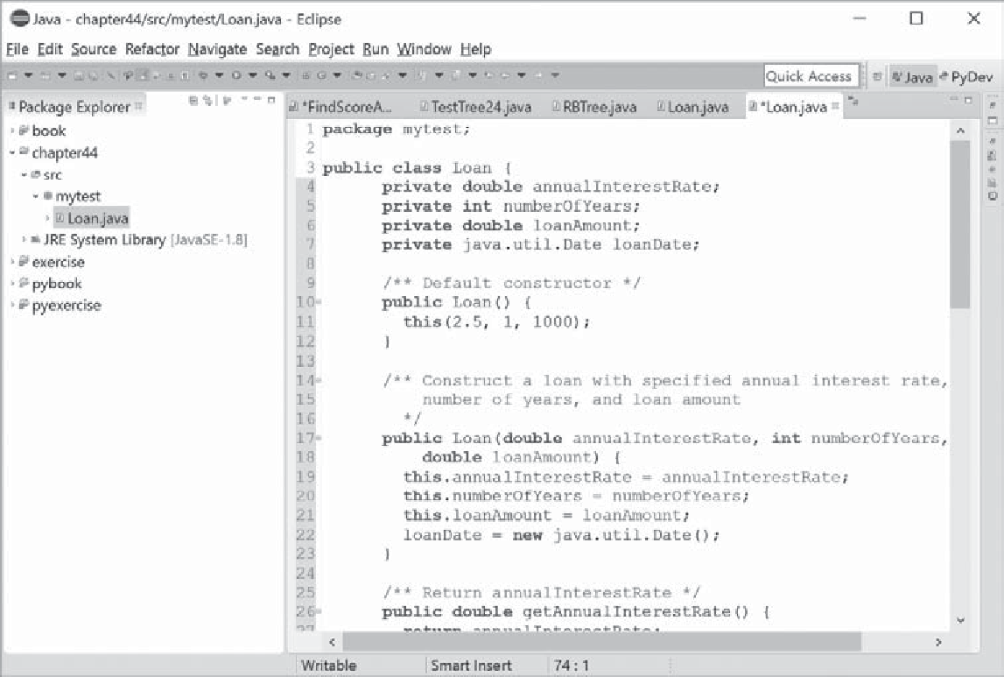

FIGuRE 44.14 The Loan class is created.



44-14 Chapter 44 Testing Using JUnit
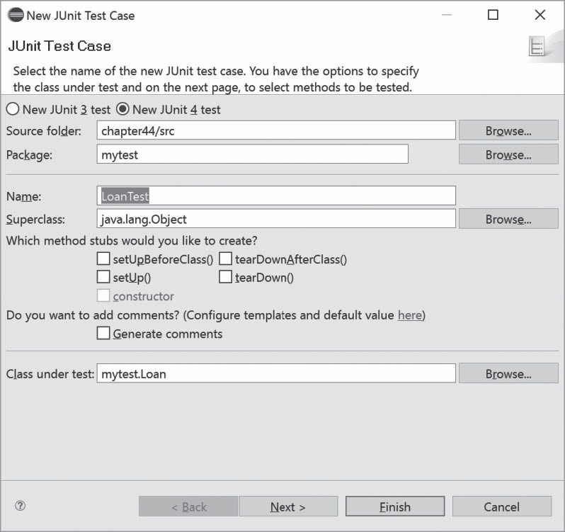
FIGuRE 44.15 The New JUnit Test Case dialog box creates a Test class.



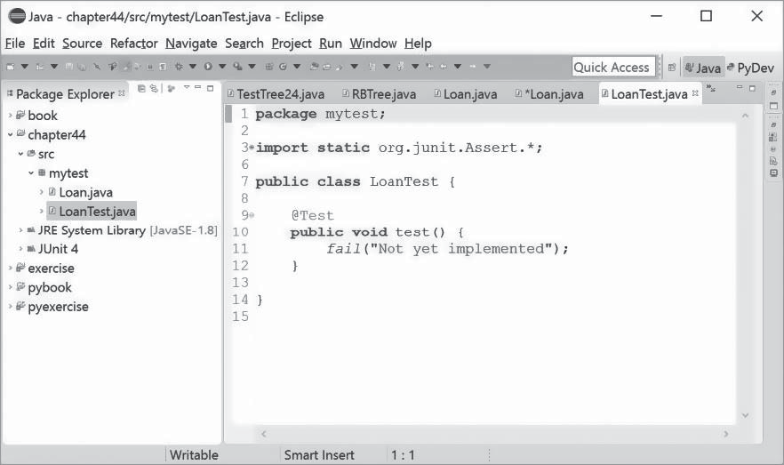
FIGuRE 44.16 The LoanTest class is automatically generated.




Programming Exercises 44-15
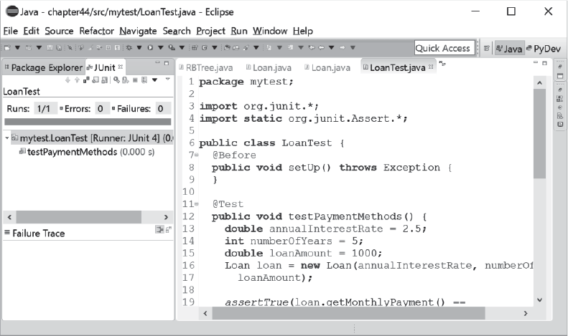
FIGuRE 44.17 The test report is displayed after the LoanTest class is executed.

CHaPTER SuMMaRy
- JUnit is an open-source framework for testing Java programs.
- To test a Java class, you create a test class for the class to be tested and use JUnit’s test runner to execute the test class to generate a test report.

- You can create and run a test class from the command window or use a tool such as NetBeans and Eclipse.
QuIZ
Answer the quiz for this chapter online at the book Companion Website.

PROgRaMMINg ExERCISES
  - Write a test class to test the methods length, charAt, substring, and indexOf
in the java.lang.String class.
  - Write a test class to test the methods add, remove, addAll, removeAll, size, isEmpty, and contains in the java.util.HashSet class.
  - Write a test class to test the method isPrime in Listing 6.7 PrimeNumberMethod. java.
  - Write a test class to test the methods getBMI and getStatus in the BMI class in Listing 10.4.




